SIMPLE CHECKMATES (Part 3)

6. Checkmate with 2 Bishops:

The mating procedure using 2 Bishops is more complicated than the previous ones but can be carried out in a series of logical steps. Both Bishops combine with the King to drive the opposing King to one of the corner and then deliver mate.

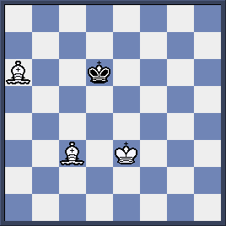

- Kd3 Kc5 2.Bc4(Bishops need to place together in order to control the movement of opposing King)2…Kd6 3.Bd4 Kc6 4.Ke4 Kd6 5.Bd5 Kd7 6.Be5 Ke7 7.Kf5 Kd7 8.Kf6! (King gains ground) 8…Kd8 9.Be6 Ke8 10.Bd6 Kd8

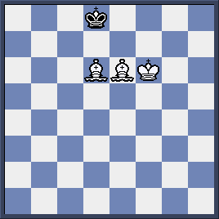

11. Be5! (A waiting move!) Ke812. Bc7! (White forces Black King to the right corner) 12…Kf8 13.Bd7 Kg8 14. Kg6 (to make sure Black King remains at the 8th rank) 14… Kf8 15.Bd6+ Kg8 16.Be6+ Kh8 17.Be5#

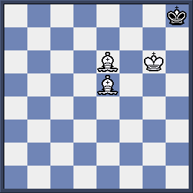

7. Checkmate with Bishop and Knight:

This is the most difficult task among checkmating the lone King. We have to combine well King, Bishop and Knight to drive opposing King to the corner squares of the same color as the Bishop. Only then we can deliver mate. Note that some time we can mate at the edge of the board but it is because opposing King made mistake earlier.

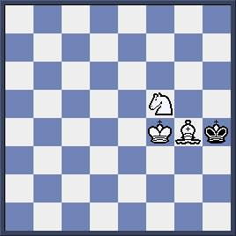

The hardest part of the mate is to force opposing King to the right corner as he always tries to move far away from it.

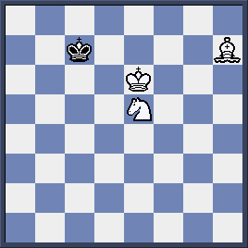

- Nd7 Kc6 2. Bd3 (to guard b5 square) Kc7 3.Be4 Kd8 4.Kd6 Ke8 5.Bg6+ Kd8 6.Nc5 Kc8 7.Bf7 Kd8 8. Nb7+ Kc8 9.Kc6 Kb8 10.Be6 Ka7 11.Nc5! (to make sure that Black King remains at the right corner) 11…Kb8 12. Kb6 Ka8 13. Bd7 (a waiting move!) Kb8 14.Na6+ Ka8 15.Bc6#
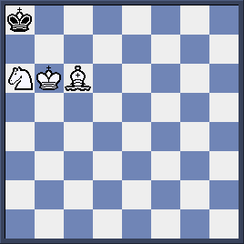

8. Endings with 2 Knights:
It is impossible to mate the opposing King with 2 Knights unless the opposing King moves to the corner.
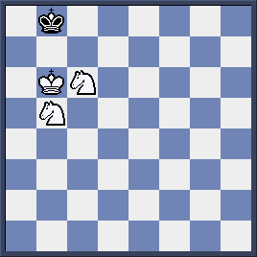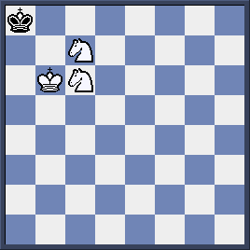
Here if Black blunders 1…Ka8?? Then White happily gives mate with 2.Nc7#. However, the right move is 1…Kc8 2.Nd6+ Kd7 and Black King move out of dangerous corner and no way White can mate.
Quiz: Can White win here?

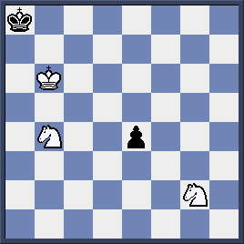
White makes use of Black pawn to set up mating net around Black King and checkmate it in-time. Let do it.
1. -----------------
- -----------------
- -----------------
- -----------------

